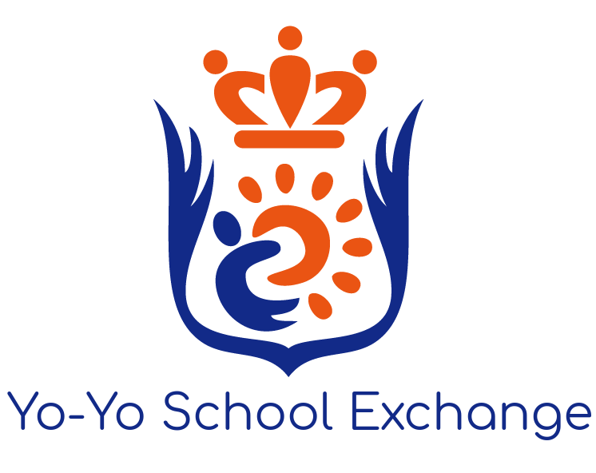
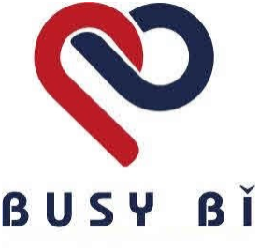

Privacy Information

V.1
19/09/2019

Yo-Yo School Exchange appreciates the tremendous responsibility that comes with the handling of personal information, especially that of children. Therefore, particular care is taken to ensure the security of all personal information at all stages.
All data storage, processing and transferring conducted by Yo-Yo School Exchange is in full compliance with the European Union General Data Protection Regulation (GDPR) and all equivalent regulations in the People’s Republic of China (Mainland China) and the Republic of China (Taiwan).
The following document details relevant Privacy Policy information.
In the event of any privacy or data protection-related concerns, Yo-Yo School Exchange staff can be contacted using the details below:

Yo-Yo School Exchange
Sixth Floor, Broad Quay House
Prince Street
Bristol
BS1 4DJ
Tel. +44 (0) 117 975 8691

Data Protection Officer: Ryan Cronin
ryan.cronin@yoyoschoolexchange.com

1. Nature and Purpose of Data Processing
All personal data of an individual held by Yo-Yo School Exchange is kept solely for the purposes of fulfilling our contractual obligations and delivering our various programmes.
Personal data is encrypted and stored securely, and accessed only when required. It undergoes no processing other than simple collation, for the purposes of ensuring the data can easily retrieved when needed. Unless otherwise stated, it is never shared with a Third Party.
At no point is any personal information stored on a member of staff’s personal computer, mobile, or any other vulnerable device.
Personal Letters provided to Yo-Yo School Exchange for the Busy Bi Pen Pal programme are collated for the purposes of producing the published Logbook.

2. Lawful Basis & Legitimate Interests
The retention, processing and transfer of an individual’s personal data for the purposes of fulfilling a contract is permitted under the GDPR Article 6(1).
Specifically, in order to deliver its various programmes, Yo-Yo School Exchange must retain key personal information. This includes:
- A student’s name & age
- (If applicable) The school they attend and through which they registered for the programme
- (School trip programme only) Emergency Contact Information
- (School trip programme only) Additional Information(*)
- (School trip programme only) A scan of the student’s passport
- (Busy Bi Pen Pal programme only) Letters written by the student
(*) This amounts to information vital to safeguarding the safety and health of the student whilst they are on a Yo-Yo School Exchange programme. This includes dietary information, allergies and other information that may require special care or attention.

3. Transfer of Data to Third-Parties
Yo-Yo School Exchange will, when required, transfer personal information to trusted partners for the purposes of delivering the programme to which the individual is a member. Mainland China and Taiwan are not subject to mutual recognition of ‘data protection adequacy’ with the EU, and are therefore considered a ‘Third Country’ under the GDPR, and the transfer of data to these countries therefore requires particular attention.
Third parties include:
- Partner schools
  - In the case of organising an exchange trip or integration activity, this will include a student’s name, age, school, and emergency contact information.
  - In the case of the Busy Bi Pen Pal programme, this will also include the personal letters written by the student for the programme.
- Various establishments and agencies required for the arrangement of exchange trips - these include hotels, restaurants, transport providers, and other entertainment or education partners
  - Only information needed for the purposes of making relevant bookings and arrangements, and safeguarding the health & safety of the participant, will be shared with the third party.
  - The information shared includes the participant’s name, age, school, emergency contact information, a scanned passport image, and any additional information required by the third party in order to protect the legitimate interests of the participant (this includes dietary information, allergies, or any other relevant health conditions or requirements).
- Graphic design partners
  - Personal Letters provided to Yo-Yo School Exchange will be shared with a graphic design partner for the purposes of producing the Logbook, as part of Yo-Yo School Exchange’s contractual obligations in delivering the programme.
  - Other information shared with the graphic design partner includes the student’s name, age at the time of the writing of the letter, and the school through which they participated in the programme.
  - No identifiable information is shared.
- Legal Authorities and Organisations
  - Personal information held by Yo-Yo School Exchange may be shared with relevant authorities where it is required of us by law, or necessary for the protection of the rights of the individual concerned.
  - Personal information may also be disclosed to legal bodies or organisations where it is deemed necessary to respond to claims asserted against us or comply with legal or investigative processes, enforce or administer our agreements and terms, conduct risk assessments, prevent potential fraud, or protect the rights, property, or safety of Yo-Yo School Exchange, its staff, its partners, and those children under its care.
All data will be transferred only to these trusted third parties and to no other body, and utmost care will be taken during the transfer process to ensure the security of the information transferred.
For the purposes of fulfilling contractual obligations to deliver the programme, personal data will be accessed by or shared with subsidiaries and affiliates of Yo-Yo School Exchange (e.g. sister organisations in Mainland China or Taiwan). This will be solely for the purpose of delivering the agreed contract, and their use of this data will be subject to the same privacy policy.
Data held by Yo-Yo School Exchange may also be disclosed or transferred as part of any merger, sale, and transfer of our assets, acquisition or restructuring of all or part of our business, bankruptcy, or similar event.
Aggregate or anonymised information may also be shared with third parties for research, marketing, analytics or other purposes, on the account that such information does not identify an individual.
During activities organised by Yo-Yo School Exchange, staff may occasionally record video or take photographs. These photographs may then be shared with parents of the children who are taking part in the exchange trip, or representatives of the partner school. Please also see section 4.

4. Publication
Unless the participating student has specifically requested otherwise, some personal letters provided to Yo-Yo School Exchange for the Busy Bi Pen Pal programme may, on occasion, be selected for use in digital marketing purposes. These letters will be used to promote Yo-Yo School Exchange, Busy Bi, and cultural exchanges between the UK and Mainland China & Taiwan. This promotion may take the form of public posts on Yo-Yo School Exchange’s public social networking accounts (Facebook, Twitter, WeChat, Weibo, LINE, and Instagram), a section on the Yo-Yo School Exchange Website, or a feature in a brochure or other publication. These letters will be displayed alongside:
- The student’s first name (surname will be removed);
- Age at the time of writing.
Those letters chosen will be carefully selected to ensure no personal information is shared (they will be redacted or anonymised if necessary). The school the student was attending at the time of writing will not be published.
Photos and videos taken by Yo-Yo School Exchange staff during exchange trips in which participants are featured may also, on occasion, be used for digital marketing processes, unless the participant (or a parent/guardian) has requested otherwise. Media selected will be published, at the very most, with the student’s first name and age at the time the photo/video was taken.

5. Retention of Personal Data
Personal data will not be retained for any period longer than necessary for the delivery of the programme in which the individual is taking/has taken part. It will then be retained for records for a further two years, to allow for review and feedback on individual programmes. After this period, all personal data will be permanently deleted.
Personal Letters provided for the Busy Bi Pen Pal programme are retained indefinitely, for the purposes of having a record that can be accessed by participant schools and students (and for occasional marketing purposes, subject to the conditions stated in item 4). This is retained alongside the following (non-identifiable) information:
- The student’s name
- Age at the time of writing
- School through which they participated in the programme

6. Rights
Under the GDPR, all individuals whose personal information is held has the right to the following:
- The right to access all information held by any organisation, and to data portability
  - This involves the right to see at any time what personal data any data controller has on an individual, and to transfer this if requested.
  - This request can be made to the Yo-Yo School Exchange Data Protection Officer, listed above.
- The right to rectification, erasure
  - An individual has the right to have any personal data corrected, or removed from the system.
  - This request can be made to the Yo-Yo School Exchange Data Protection Officer, listed above.
- The right to object to any information storage or processing, or to withdraw consent
  - This request can be made to the Yo-Yo School Exchange Data Protection Officer, listed above. Due to the nature of the programmes organised by Yo-Yo School Exchange, this will often necessitate the withdrawal of the individual from the programme for which the information was retained.
- The right to lodge a complaint with a supervisory authority
  - Individuals have a right to raise a data protection complaint with the supervisory authority where they live, work, or where an infringement took place.
  - Residents of the UK can make a complaint to the Information Commissioner’s Office: ico.org.uk.

INews Media LTD t/a Yo-Yo School Exchange.
Registered office: Regina House, 124 Finchley Road, London, NW3 5JS. Registered in England.
Registered number: 08641027.

